
AI - BASED ELECTRICAL FIRE PREVENTION SYSTEM USING IOT SENSORS AND MACHINE LEARNING
SURABHI KERKETTA – 24619257
RITHIKA G – 24619245
VAGITHA RIFANA – 24619258
VELS INSTITUTE OF SCIENCE, TECHNOLOGY & ADVANCED STUDIES (VISTAS)
MINI PROJECT REPORT
Submitted to the
SCHOOL OF ENGINEERING
DEPARTMENT OF ARTIFICIAL INTELLIGENCE AND MACHINE LEARNING
in Partial fulfillment of the requirements for the award of the degree of
BACHELOR OF TECHNOLOGY
IN
COMPUTER SCIENCE AND ENGINEERING

ARTIFICIAL INTELLIGENCE AND MACHINE LEARNING
VELS INSTITUTE OF SCIENCE, TECHNOLOGY AND ADVANCED STUDIES (VISTAS)
CHENNAI – 600 117
OCTOBER 2026
BONAFIDE CERTIFICATE
Certified that this project report "AI - BASED ELECTRICAL FIRE PREVENTION SYSTEM USING IOT SENSORS AND MACHINE LEARNING", is the Bonafide work of SURABHI KERKETTA – 24619257, RITHIKA G – 24619245, VAGITHA RIFANA – 24619258 who carried out the project under my supervision. Certified further, that to the best of my knowledge the work reported here does not form part of any other project report or dissertation on the basis of which a degree or award was conferred on an earlier occasion on this or any other candidate.

SIGNATURE OF THE HOD SIGNATURE OF THE SUPERVISOR
Dr. K. Ulaga Priya M.E., Ph.D Dr. G. REVATHY M.E., Ph.D
Associate Professor & Head Assistant Professor
Department AI&ML Department of AI&ML
School of Engineering School of Engineering
VISTAS VISTAS
Chennai Chennai
Submitted for the Project Work and Viva – Voce examination held on ....................... at Vels Institute of Science, Technology and Advanced Studies (VISTAS), Chennai – 600 117.

INTERNAL EXAMINER EXTERNAL EXAMINER
ACKNOWLEDGEMENT
It is certainly a great delight and proud privilege to acknowledge the help and support we received from the positive minds around us in making this venture a successful one. The infrastructural support with all kinds of lab facilities has been a motivating factor in the completion of this project work, all because of our FOUNDER & CHAIRMAN, Shri. Dr. ISHARI K. GANESH, and it is with great pleasure that we take this opportunity to thank him. We are grateful to our HEAD OF THE DEPARTMENT, Dr. K. Ulaga Priya, for her continuous support for the project, from initial advice and contacts in the early stages of conceptual inception, and through on-going advice and encouragement to this day. We extend our warmest thanks to our INTERNAL GUIDE, Dr. G. REVATHY, Assistant Professor/AI&ML, who has patiently guided us and provided invaluable advice and help. We would like to express our greatest gratitude to our Staff members, Librarian, and Non-teaching staff members of the Computer Centre, who have helped and supported us throughout. Last but not the least, we wish to thank our parents and our friends for their individual support and interest, who have inspired us and encouraged us to go our own way; without them we would be unable to complete this project.
SURABHI KERKETTA – 24619257
RITHIKA G – 24619245
VAGITHA RIFANA – 24619258

CHAPTER NO. | TABLE OF CONTENT | PAGE NO.
 | ABSTRACT | i
 | LIST OF FIGURES | ii
 | LIST OF TABLES | ii
 | ABBREVIATIONS | iii
1 | INTRODUCTION | 1
 | 1.1 Overview of the project | 1
 | 1.2 Scope and objective | 2
2 | LITERATURE REVIEW | 5
 | 2.1 Literature Overview | 6
 | 2.2 Literature Survey | 6
3 | SYSTEM DESIGN | 12
 | 3.1 Existing System | 12
 | 3.2 Proposed System | 12
 | 3.3 System Architecture | 13
 | 3.4 Hardware Requirements | 15
 | 3.5 Software Requirements | 16
4 | APPROACH AND EXECUTION | 18
 | 4.1 Methodology | 18
 | 4.2 Implementation | 19
 | 4.2.1 Dataset Generation & Model Training Module | 20
 | 4.2.2 Embedded Risk Classification Module | 20
 | 4.2.3 Alert & Protection Module | 20
 | 4.2.4 GSM Alert & Data Logging Module | 21
 | 4.3 Source Code | 21
5 | RESULT ANALYSIS | 23
6 | CONCLUSION AND FUTURE WORK | 26
 | 6.1 Conclusion | 26
 | 6.2 Future Work | 26
 | REFERENCES | 28

ABSTRACT
Electrical fires are often caused by electrical and environmental conditions and are not detected until the smoke and flames of the fire start. To address this issue, we have created a prototype that monitors the temperature, voltage, current and smoke of an electrical device using the ESP32 IoT platform. An machine learning model classifies the risk of the situation into four levels of risk safe,warning,high risk or critical. We created a data set of 6,400 samples to train the machine learning model. The random forest model that was trained with the data set achieved an accuracy of 99.06%. However, for the embedded device that we created, a decision tree model was used which achieved an accuracy of 98.12%. When the system detects a state that indicates a potential fire, it will trigger a relay switch that cuts the power to the electrical device. In addition, a buzzer will sound and an SMS message will be sent to a designated phone number via the SIM800L GSM module. All sensor readings and events that occur are also logged. We tested our prototype in a controlled environment. This is a student prototype and is not intended to be used for high current applications.

Keywords: Fire prevention, ESP32, Internet of Things, Machine learning, Decision Tree, Random Forest, Multi-sensor monitoring GSM alert

(i)
LIST OF FIGURES
FIGURE NO | NAME | PAGE NO.
3.1 | System Architecture of AI-Based Electrical Fire Prevention System | 13
3.2 | System Flow | 14
5.1 | Confusion Matrix | 23
5.2 | Pre Class Precision | 23
5.3 | Class Distribution | 24
5.4 | Final Output of AI-Based Electrical Fire Prevention System | 25

LIST OF TABLES
TABLE NO | NAME | PAGE NO.
2.1 | Summary of related work | 9
3.1 | Prototype Hardware Configuration | 15
3.2 | Development Computer | 15
3.3 | Software tools | 15

(ii)
ABBREVIATIONS
Abbreviation | Full Form
AI | Artificial Intelligence
ML | Machine Learning
IoT | Internet of Things
ESP32 | Espressif Systems 32-bit MicroController
GSM | Global System for Mobile Communications
SMS | Short Message Service
SIM | Subscriber Identify Module
LCD | Liquid Crystal Display
I2C | Inter-Integrated Circuit
ADC | Analog-to-Digital Converter
GPIO | General Purpose Input/Output
DT | Decision Tree
SVM | Support Vector Machine
CNN | Convolutional Neural Network
YOLO | You Only Look Once
MCB | Miniature Circuit Breaker
BLE | Bluetooth Low Energy
IDE | Integrated Development Environment
USB | Universal Serial Bus
RAM | Random Access Memory
SSD | Solid State Drive

(iii)

CHAPTER 1
INTRODUCTION

1.1 OVERVIEW OF THE PROJECT

Introduction
Electrical fires are one of the leading causes of property damage and loss of life,often resulting from unnoticed electrical faults. Traditional fire alarm systems are mainly reactive, as they detect smoke or flames only after a fire has already started. This project aims to shift from reactive fire detection to proactive fire prevention by using real-time sensor data and Machine Learning to predict potential fire risks before ignition occurs. An ESP32-based IoT system continuously monitors important electrical and environmental parameters such as temperature, voltage, current, and smoke to identify abnormal conditions. Based on the collected data, the system automatically classifies the level of fire risk and takes preventive actions, including power disconnection, buzzer activation, and SMS alerts, thereby improving electrical safety and enabling early intervention.

Problem Statement
Traditional electrical fire prevention systems rely on basic protective devices such as fuses, circuit breakers, and manual monitoring. These systems have certain limitations in identifying potential electrical fire hazards at an early stage:
- Delayed Detection: Traditional systems may detect faults only after abnormal electrical conditions become severe, reducing the time available for preventive action.

- Limited Monitoring: Conventional systems may not continuously monitor important parameters such as temperature, current, voltage, and smoke to identify early warning signs.

- Lack of Intelligent Prediction: Basic protective devices cannot classify different levels of electrical risk using machine learning techniques, which limits proactive hazard identification.

- Delayed Alert Notification: Without an integrated alert system, users may not receive immediate notifications about dangerous electrical conditions.

These limitations can increase the risk of electrical fires, equipment damage, and safety hazards. The core problem is the lack of an intelligent, continuous monitoring system that can detect abnormal electrical conditions, classify risk levels, and provide timely alerts to enable early intervention and improve electrical safety.

Objectives of the Project
The main objectives of this project are:
- Monitor temperature, current, voltage and smoke using sensors connected to an ESP32.
- Develop and evaluate Random Forest and Decision Tree classifiers using a 6,400-sample synthetic dataset.
- Classify sensor patterns into Safe, Warning, High Risk and Critical categories.
- Demonstrate relay control and buzzer activation for a critical risk state.
- Send SMS notifications through a SIM800L GSM module without requiring Wi-Fi or internet access for messaging.
- Display the current risk state and record sensor readings, classifications and system events.
- Assess the prototype’s strengths, limitations and future validation needs.

System Overview
The system integrates the following major components:
- Sensor Monitoring and Data Collection: The system uses temperature, current, voltage, and smoke sensors to collect electrical parameters in real time.
- Risk Level Analysis: A machine learning model analyzes the collected sensor data and classifies electrical conditions into four categories: Safe, Warning, High Risk, and Critical.
- Alert and Protection System: When a dangerous condition is detected, the system activates a buzzer and relay and sends an SMS notification through the GSM module to alert users.

1.2 SCOPE AND OBJECTIVE

Purpose of the Study
The main purpose of this project is to design, implement, and evaluate an AI-based electrical fire prevention system using IoT sensors and machine learning. The system aims to improve electrical safety by continuously monitoring temperature, current, voltage, and smoke levels. It identifies abnormal electrical conditions, classifies potential risk levels, and generates timely alerts to support early intervention.
This is achieved by:
- Real-time monitoring of electrical parameters using IoT sensors.
- Early identification of abnormal conditions that may indicate electrical hazards.
- Using machine learning techniques to classify electrical risk levels.
- Generating automatic alerts through a buzzer, relay, and GSM-based SMS notifications.

General Objective
The general objective is to develop an intelligent and efficient electrical fire prevention system that continuously monitors electrical conditions, identifies potential hazards, and provides timely alerts to improve safety and reduce the risk of electrical fires.

Specific Objectives
- To develop a system capable of collecting real-time temperature, current, voltage, and smoke readings using IoT sensors.
- To train and evaluate machine learning models for classifying electrical conditions into Safe, Warning, High Risk, and Critical categories.
- To implement sensor data processing and risk classification using an ESP32 microcontroller.
- To design an alert mechanism using a buzzer, relay, LCD, and GSM module.
- To record sensor readings and detected risk levels for monitoring and analysis.
- To evaluate the performance of the machine learning models using accuracy and other classification metrics.

Scope of the Project
The scope defines the functional Capabilities, technical boundaries and applications of the system.
A. Functional Scope
- Data Monitoring: The system continuously monitors the collected sensor values to identify abnormal electrical conditions.

- Risk Classification: The machine learning model classifies electrical conditions into four categories: Safe, Warning, High Risk, and Critical.

- Alert Generation: When dangerous conditions are detected, the system activates buzzer and uses the relay for the intended protective response.

- SMS Notification: The GSM module sends SMS alerts to notify users about detected electrical hazards.

- Data Logging: Sensor readings and risk classifications can be recorded for future analysis and system evaluation.
B. Technical Scope
- Hardware: The system uses an ESP32 microcontroller, temperature sensor, current sensor, voltage sensor, smoke sensor, relay, buzzer, LCD, and GSM module.

- Machine Learning: A Decision Tree model is deployed on the ESP32 for risk classification, while a Random Forest model is used for offline evaluation.

- Data Processing: Sensor readings are processed and analyzed to identify patterns associated with different electrical risk levels.

- Communication: The GSM module supports SMS-based alert notification.

- Monitoring: The LCD displays relevant readings or system status, depending on the implemented interface.
C. Application Scope
- Residential Buildings: To monitor electrical conditions and provide early warnings about potential hazards.

- Offices and Commercial Buildings: To identify abnormal electrical readings in monitored circuits.

- Laboratories: To improve electrical safety around equipment and experimental setups.

- Small Industrial Environments: To monitor selected electrical equipment and identify potentially unsafe conditions.

The prototype requires further testing and appropriate electrical protection measures before deployment in real-world high-current environments.

Importance of the Project
Electrical faults such as overheating, excessive current, abnormal voltage, and smoke can lead to electrical fires and equipment damage. This project uses IoT sensors and machine learning to identify potential hazards and classify risk levels. The key benefits include improved electrical safety, early hazard detection, and faster response through automatic buzzer and SMS alerts.

Challenges and Limitations
- Sensor accuracy may be affected by calibration, electrical noise, and environmental conditions.

- Machine learning performance depends on the quality and diversity of the training dataset.

- Synthetic dataset results may not fully represent real-world electrical faults.

- GSM notifications depend on network availability and module configuration.

- Incorrect sensor readings or unsuitable thresholds may lead to false alerts or missed hazards.

- The prototype is not a certified replacement for circuit breakers, residual-current protection, or other required electrical safety devices.

- Real-world deployment requires electrical safety testing and validation under appropriate conditions.

CHAPTER 2

LITERATURE REVIEW

2.1 LITERATURE OVERVIEW
Fire detection has moved from single-sensor alarms (ionization, photoelectric and heat detectors) to IoT-based monitoring and, more recently, to machine-learning models that combine several signals [5]. Electrical faults such as overloaded circuits, loose connections and worn insulation are a leading and largely preventable cause of building fires; a national study reported that they made up 42.7% of residential fires in China between 2012 and 2021 [2]. These faults usually pass through a pre-ignition stage in which temperature, current and voltage behave abnormally before smoke or flame appears [3], yet conventional alarms respond only after burning has begun. Most published work either relies on fixed thresholds, needs costly hardware or cloud infrastructure, or has been validated only in simulation.
This literature review focuses on IoT-based fire prevention, electrical fire monitoring and early warning, machine learning for electrical fire prediction, deep learning and multi-sensor fusion, building fire safety and evacuation, and embedded deployment with offline alerting. The goal is to identify the research gap that this project aims to fill.
This review serves multiple purposes:
- To identify the research gap in existing fire detection and electrical fire prevention systems.
- To understand how multi-sensor data and machine-learning classifiers have been used for early warning.
- To understand what is needed to run a classifier on a low-cost microcontroller.
- To provide the theoretical foundation and justification for the proposed system.

2.2 LITERATURE SURVEY
The literature survey is organized into thematic sub-sections to provide a structured understanding of related research, covering threshold-based IoT systems, machine learning, sensor fusion, embedded deployment, and offline alerting.
A. IoT-Based Fire Detection and Prevention
Mbale and Simbeye [1] developed an Arduino-based fire prevention system using gas, smoke, and heat sensors with automatic suppression. Hazard thresholds were set at 60°C, 300 ppm gas, and 40% smoke opacity, with suppression activated when at least two sensors agreed. In 240 simulated observations, detection-to-alert time decreased from 180 seconds to 18 seconds. Earlier work [13] established this sensing-and-alert approach, while recent studies introduced computer vision using ESP32 for Indian micro and small enterprises [8] and multi-sensor detection with automatic suppression and electrical isolation [10]. These studies demonstrate the suitability of low-cost boards, although [1] relies on fixed thresholds and simulated data.
B. Electrical Fire Monitoring and Early Warning
Ma et al. [2] combined electrical monitoring, arc detection, and smart circuit breakers in an EC-IoT cloud-edge-terminal system for high-rise residential buildings, using digital building simulation for early warning. Related studies explored edge computing for ancient buildings [14], mathematical temperature prediction for resistive circuit fires [11], and electrical fire-risk prediction using firefighting big data [12]. These works demonstrate the value of electrical parameters and temperature for early warning but focus on building-scale infrastructure, mathematical models, or large datasets rather than small standalone nodes.
C. Machine Learning for Electrical Fire Prediction
Pekşen et al. [3] monitored an electrical panel using Arduino Mega, Raspberry Pi 4, and DHT22, MQ135, MQ4, PZEM-004T, and MLX90640 sensors. They collected 3,478 samples, including 3,025 normal and 453 pre-ignition samples, and compared Decision Tree, Gaussian Naive Bayes, Gaussian Process Classifier, and SVM using five-fold cross-validation and recursive feature elimination. The Gaussian Process Classifier performed best. However, limited later-stage fire samples restricted classification to two classes, and data came from one experimental panel. Other studies investigated machine learning for electrical fire prediction [17], extreme learning machines with gas detection [16], and AI-based multi-sensor fusion in smart buildings [15]. These studies support learning-based early warning and motivate the graded, multi-level classification used in this project.
D. Deep Learning and Multi-Sensor Fusion
Emmanuel et al. [5] reviewed the shift from single-sensor alarms to CNN-based visual detection using YOLO, ResNet, and MobileNet, alongside multi-sensor fusion. They reported false alarm rates reaching 95% in some jurisdictions and discussed signal-, feature-, and decision-level fusion using Kalman filtering, Dempster-Shafer, and Bayesian methods. Neural-network fusion of temperature, smoke, and carbon monoxide data reduced detection time by 32% compared with single-sensor systems. However, integrated systems combining fusion, IoT connectivity, and embedded deployment remain underdeveloped, with limited benchmarks and field validation. Deep-learning fire detection [7] and reviews of early fire and smoke detection models, datasets, and challenges [9] mainly focus on vision-based methods, which can be computationally demanding for embedded devices.
E. Building Fire Safety, Evacuation and Facility Management
Andil et al. [4] combined wireless sensor networks, BLE beacons, and ESP32 or Raspberry Pi boards with AI-based path finding to guide occupants along safe evacuation routes. However, the prototype had limited real-world validation, high processing needs, and privacy concerns. Xu et al. [6] studied AI-based fire-safety facility supervision through questionnaires, interviews, and field visits in two public buildings, collecting 91 valid questionnaires. Their findings showed improved management efficiency and accuracy, although staff training remained a challenge. Both studies highlight the importance of automated monitoring and timely, reliable fire detection.
F. Embedded Deployment and Offline Alerting
Emmanuel et al. [5] discussed model optimization techniques such as quantization, pruning, and TensorFlow Lite for Microcontrollers for devices with limited memory. Edge processing reduces latency and enables operation during network failures, while SIM900 GSM modules send SMS alerts without internet connectivity. Unlike the cloud-based alert system in [1], these findings support running a small model directly on the microcontroller and sending alerts through GSM.

Summary Table of Related Work
Table 2.1 summarizes the key studies reviewed, with their authors, methodology, datasets, limitations and the gap each addresses.
Table 2.1 – Summary of related work
TITLE | AUTHOR | METHODOLOGY | DATA SET | LIMITATION | ADDRESSES
[1] Development of an Intelligent Fire Prevention System Using IoT-Enabled Sensors and Automated Countermeasures | Jameson Mbale, Ndanji Simbeye. 2025 | Arduino with IoT sensors, threshold logic, cloud alerts and automated suppression; High/Low risk classification. | 240 simulated observations of temperature, gas and smoke. | Simulated data needs real-world pilot testing; power, false-positive and cost issues. | Low-cost real-time fire prevention with automated response.
[2] Application of an Intelligent Electrical Fire Monitoring System Based on the EC-IoT Framework in High-Rise Residential Buildings | Mengying Ma, Chengdi Xu, Junfeng Han. 2025 | EC-IoT cloud-edge-terminal architecture with Modbus edge response, arc detection, smart circuit breakers and BIM simulation. | No public ML dataset; electrical monitoring data and digital building simulation. | Focuses mainly on electrical parameters; limited multi-source data integration. | Early warning of electrical fires in high-rise residential buildings.
[3] Enhancing Electrical Panel Anomaly Detection for Predictive Maintenance with Machine Learning and IoT | Muhammed Fatih Peksen, Ulaş Yurtsever, Yılmaz Uyaroğlu. 2024 | Arduino Mega and Raspberry Pi 4 with DHT22, MQ135, MQ4, PZEM-004T and MLX90640; DT, GNB, GPC and SVM with 5-fold cross-validation and RFE. | 3,478 experimental samples: 3,025 normal and 453 pre-ignition. | Binary classification only; data specific to one experimental panel. | Predicts electrical panel anomalies and pre-ignition risk; GPC performed best.
[4] AI Based Fire Detection and Control System for an Indoor Positioning System | Abhishek Andil, Pranav Bhalerao, Gaurav Raygade, Saurav Bhosale, Pradnya Kasture. 2025 | WSN, BLE beacons, ESP32/Raspberry Pi and AI-based pathfinding for fire detection and evacuation routing. | No public benchmark; sensor, fire-condition and indoor location data. | Prototype level; limited real-world validation; high processing, privacy and interoperability concerns. | Real-time indoor fire detection with location-based evacuation routes.
[5] Intelligent Fire Detection Systems Using Deep Learning and Multi-Sensor Data Fusion: A Comprehensive Review | Gwamzhi Ponsah Emmanuel et al. 2025 | CNN, YOLO, ResNet, MobileNet and IoT with multi-sensor fusion (Kalman, Bayesian, knowledge distillation). | FireNet, BoWFire, FASDD, D-Fire, PYRONEAR and other public fire/smoke datasets. | High computation; limited standardization and real-world validation. | Combines sensors and AI to improve robustness and reduce false alarms.
[6] Effectiveness Study of Artificial Intelligent Facility System in Maintaining Building Fire Safety | Weijie Xu, S. C. Chan, W. Y. Leong. 2023 | Mixed methods: questionnaires, interviews, field investigation and comparative case study. | 91 valid questionnaires from two public buildings, plus interviews and field data. | Small sample, limited geographical coverage and case-study based. | Evaluates AI in fire-fighting facility supervision, maintenance and staff training.
[7] Fire Detection Using Deep Learning Methods | Aigulim Bayegizova et al. 2024 | YOLOv4, CNN and Fast R-CNN on satellite and FireWatch images. | Satellite and FireWatch images; Kaggle image datasets. | Small or short fires are hard to detect in satellite images; FireWatch coverage and cost limits. | Fast automated wildfire detection; YOLOv4 reported 98.9% accuracy.

Research Gaps Identified
- Fixed Thresholds: some prevention systems decide with a fixed limit per sensor which can raise false alarms or miss faults that develop through a combination of readings.
- Few Risk Levels: the closest machine-learning work reduces the problem to two classes, normal and pre-ignition and does not give a graded response.
- Heavy or Cloud-Dependent Designs: several systems depend on cloud platforms or heavier hardware such as a Raspberry Pi, a thermal camera or a sensor network.
- Simulation and Limited Field Validation: results are often simulated and reviews note the lack of standard benchmarks and field validation
- Few Integrated Low-Cost Systems: integrated systems that combine multi-sensor fusion, embedded machine learning and IoT connectivity remain underdeveloped.

This project uses an ESP32 for four-parameter sensing (temperature, current, voltage, and smoke), four-level risk classification, automatic relay cut-off, buzzer alerts, and GSM-based SMS alerts without internet dependency. A synthetic dataset is used for training due to the risks of creating real faults; live hardware validation remains future work.

Summary of Literature Findings
The reviewed literature shows the evolution of fire detection from single-sensor alarms to IoT, machine learning, and multi-sensor fusion. However, few studies offer a low-cost standalone system combining electrical and environmental sensing, graded risk classification, automatic response, and offline alerts. This project addresses this gap through a complete embedded solution.

CHAPTER 3
SYSTEM DESIGN

3.1 EXISTING SYSTEM

Overview
Existing protection against electrical fires falls into three groups: (i) protective devices such as fuses, miniature circuit breakers (MCB) and residual-current devices that interrupt the supply when a fixed current or leakage limit is crossed, (ii) standalone smoke and heat detectors that raise an alarm only after combustion has started, and (iii) periodic manual inspection of wiring and appliances. Each of these reacts to a single condition, and most act only after the damage process has already begun.

Limitations of Existing Systems
- Reactive Operation: smoke detectors respond after burning or heating has started, so they give little time to prevent the fire.
- Single-Parameter Thresholds: fuses and breakers respond to current alone and do not consider temperature, voltage or smoke together.
- No Prediction: a slow rise in temperature or a gradual overload may stay below the trip limit while still creating a hazard.
- No Graded Response: the response is usually on or off, with no intermediate warning levels.
- Local Alarm Only: an alarm is useless if nobody is present, and most simple systems cannot notify the owner remotely.

Common Issues in Existing Systems
- No combined analysis of temperature, current, voltage and smoke, and no early warning before the protective device trips.
- No event record to help find the cause of repeated faults.
- Smart monitoring products depend on Wi-Fi or cloud services and are costly for small buildings.
The existing systems are therefore insufficient for predicting and preventing electrical fires at an early stage.

3.2 PROPOSED SYSTEM

Overview
The proposed system is an AI-Based Predictive Electrical Fault and Fire Prevention System. An ESP32 microcontroller continuously reads temperature, current, voltage and smoke level from four sensors. A machine-learning model trained offline analyses the four readings together and classifies the condition into one of four risk levels: Safe, Warning, High Risk or Critical. The classification runs directly on the ESP32, so no internet connection is needed for the decision. Depending on the level, the system shows the status on an LCD, sounds a buzzer, sends an SMS through a GSM module and, at the Critical level, cuts off the power with a relay.

Objectives
- To monitor temperature, current, voltage and smoke continuously and classify the condition into four risk levels using a machine-learning model.
- To run the model on the microcontroller itself for fast, offline decisions.
- To cut the power automatically at the Critical level, alert the owner by SMS and record events for later analysis.

Features of the Proposed System
- Multi-Sensor Fusion: four parameters are analysed together instead of one threshold.
- Four-Level Risk Classification: Safe, Warning, High Risk and Critical.
- Edge Inference: a small Decision Tree exported as C++ runs on the ESP32.
- Automatic Protection: a relay disconnects the supply at the Critical level.
- Local and Remote Alerts: LCD, buzzer and SMS through the SIM800L module.
- Offline Operation: the GSM network is used for alerts, so Wi-Fi and internet are not required.
- Event Logging: each reading and its risk level are logged for later analysis.

Advantages and Applications
The system detects developing faults before a fire starts, uses low-cost and easily available components, gives graded warnings instead of an on-off response and works without internet. It suits homes and apartments, shops, offices and small industrial units, electrical panels and distribution boards, and server rooms, laboratories and storage areas.

3.3 SYSTEM ARCHITECTURE

Architectural Overview
The architecture is layered and consists of four runtime layers and an offline machine-learning pipeline, as shown in Figure 3.1. Each layer can be developed, tested and replaced independently.
- Sensor Layer: a DS18B20 temperature sensor, an ACS712 current sensor, a ZMPT101B voltage sensor and an MQ-2 smoke sensor continuously monitor the electrical parameters.
- Edge Processing Layer: the ESP32 microcontroller collects and conditions the readings into a feature set (temperature, current, voltage and smoke level) and passes it to the on-device model, which predicts the fire-risk level in four classes.
- Communication Layer: the SIM800L GSM module sends text messages to the registered phone number.
- Alert and Action Layer: a buzzer, a relay for cutting off the power, SMS alerts, event logging and an LCD display.
- Machine Learning Model (Trained Offline): data collection, preprocessing, model training, evaluation and export of the trained model for ESP32 inference.

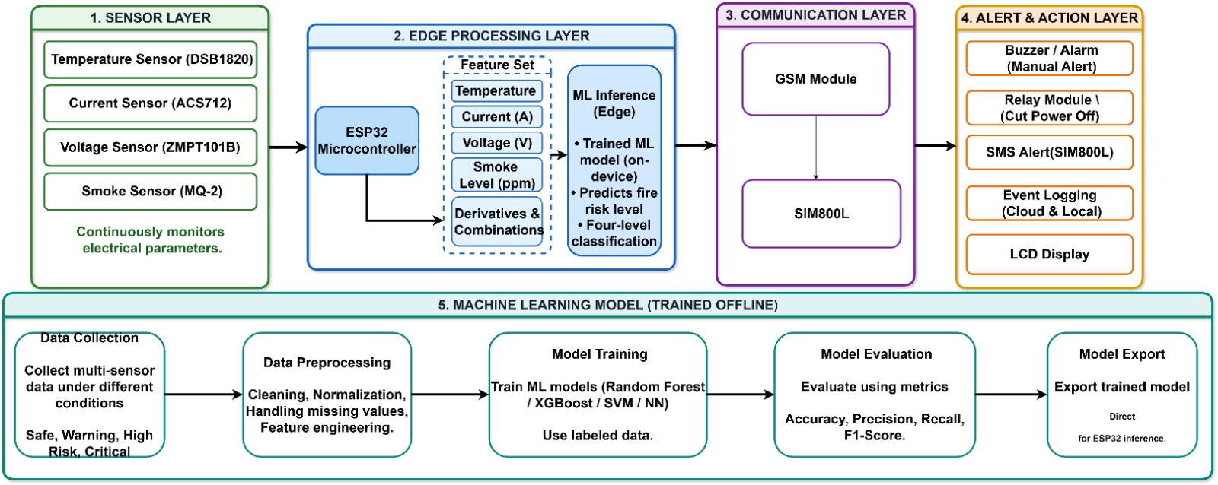
Figure 3.1 – System Architecture of AI-Based Electrical Fire Prevention System

Architectural Flow
Figure 3.2 shows the operating flow of the system as a continuous monitoring loop.
- Step 1: Sensing: the sensors measure temperature, current, voltage and smoke level.
- Step 2: Data Acquisition and Preprocessing: the ESP32 reads the sensors every 3 seconds, converts the ADC values into engineering units and limits them to the valid range used in training.
- Step 3: ML Pattern Analysis: the model analyses the combination of the four values, instead of each value on its own, to recognise the pattern of a developing fault.
- Step 4: Risk Classification: the model outputs one of four classes: Safe, Warning, High Risk or Critical.
- Step 5: Decision: the system checks whether the level is Critical. For lower levels, the status is shown, the lower-level alerts are issued and the event is logged before monitoring continues.
- Step 6: Automated Response: at the Critical level, the relay cuts the power, the buzzer sounds and an SMS is sent through the GSM module to the registered contact.
- Step 7: Event Logging and Continued Monitoring: the reading and the risk level are logged, and the loop returns to the sensors so that monitoring continues.

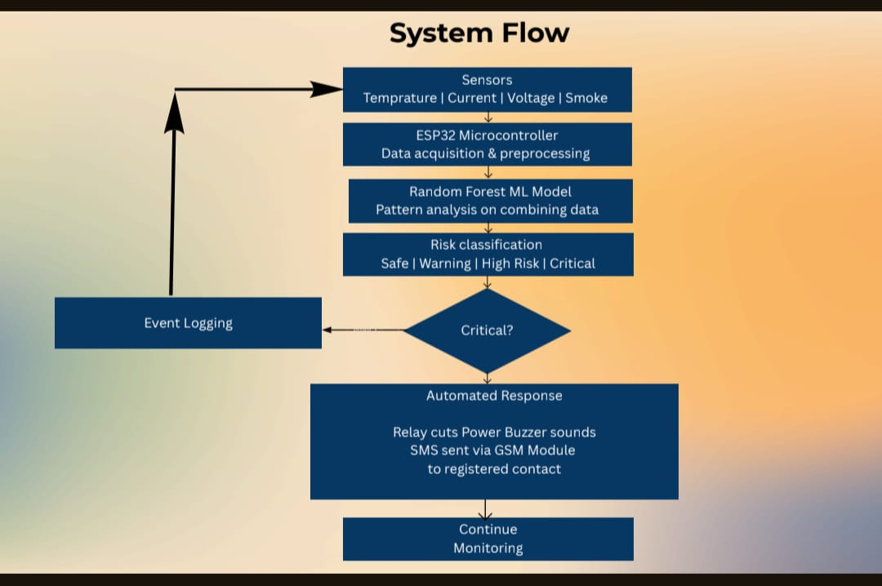
Figure 3.2 – System Flow

Machine Learning Pipeline
The lower part of Figure 3.1 shows the offline pipeline used to build the model.
- Data Collection: multi-sensor data is prepared for the four conditions Safe, Warning, High Risk and Critical. In this work a 6,400-sample dataset is generated in Python.
- Data Preprocessing: cleaning, value clipping to sensor limits and an 80:20 stratified train-test split.
- Model Training: a Random Forest (150 trees, depth 10) for offline analysis and a Decision Tree (depth 6) for the ESP32 are trained on the labelled data.
- Model Evaluation: accuracy, precision, recall, F1-score and the confusion matrix are calculated on the test set.
- Model Export: the trained Decision Tree is converted to a C++ header (FireRiskModel.h) for direct inference on the ESP32.

Safety Considerations
- The relay switches mains power, so the high-voltage side must be insulated and tested with a low-power load first.
- The current and voltage sensors must be calibrated before use.
- The system is a prototype aid and does not replace certified protective devices such as MCBs.

3.4 HARDWARE REQUIREMENTS
Table 3.1 Prototype Hardware Configuration
Component | Specification / Purpose
Microcontroller | ESP32 DevKit (ESP32-WROOM), 3.3 V logic, 12-bit ADC; data acquisition and model inference
Temperature Sensor | DS18B20 digital one-wire sensor with a pull-up resistor; measures temperature
Current Sensor | ACS712-30A hall-effect module (66 mV/A, 2.5 V at zero current); measures load current
Voltage Sensor | ZMPT101B AC voltage sensor module; measures supply voltage
Smoke Sensor | MQ-2 gas and smoke sensor with analog output; detects smoke
Relay Module | Single-channel relay; disconnects the supply at the Critical level
Buzzer | Active buzzer; audible alarm
Display | 16x2 LCD with I2C interface (address 0x27); shows status and readings
GSM Module | SIM800L with an active SIM card; sends SMS alerts without internet
Power Supply | Regulated 5 V supply for the board and modules, with a separate supply able to meet the peak current of the SIM800L
Test Load | Low-power resistive load or lamp for safe demonstration

Table 3.2 Development Computer
Component | Specification
Processor | Intel Core i5 / AMD Ryzen 5 or equivalent
RAM | 8 GB
Storage | 256 GB SSD
Interface | USB cable for programming and serial monitoring

Hardware Justification: the ESP32 has sufficient ADC channels, processing speed and memory for the four sensors and the shallow Decision Tree, and it needs no external machine-learning hardware. The SIM800L allows alerts where Wi-Fi is not available, and the relay provides the physical protection action.

3.5 SOFTWARE REQUIREMENTS
Table 3.3 Software tools
Software | Description
Operating System | Windows 10/11, macOS or Ubuntu 20.04
Python 3.10+ | Programming language for dataset generation and model training
NumPy, pandas | Dataset generation and handling
scikit-learn | Random Forest and Decision Tree training, metrics and train-test split
joblib | Saving the trained Random Forest (.pkl)
micromlgen | Exporting the Decision Tree as a C++ header for the ESP32
Arduino IDE with ESP32 board package | C++ firmware development and upload
OneWire, DallasTemperature | DS18B20 temperature sensor drivers
LiquidCrystal_I2C, Wire | I2C LCD control
HardwareSerial | Serial2 communication with the SIM800L (AT commands)

Software Modules
- generate_dataset.py: creates the 6,400-sample electrical_fire_dataset.csv with four risk classes and borderline samples.
- train_model.py: splits the data 80:20, trains the Random Forest and Decision Tree, writes model_report.txt, saves fire_risk_model.pkl and exports FireRiskModel.h.
- FireRiskModel.h: the Decision Tree as C++ code with a predict() function used on the ESP32.
- esp32_fire_prevention.ino: firmware that reads the sensors, runs the model, drives the LCD, buzzer, relay and GSM module, and writes log lines to the serial port.
- model_report.txt: accuracy, classification report and confusion matrix of the trained models.

CHAPTER 4
APPROACH AND EXECUTION

4.1 METHODOLOGY
The proposed system uses an ESP32-based architecture that integrates IoT sensors and a machine learning model for electrical fire-risk classification. The methodology consists of sensor data acquisition, dataset generation and preprocessing, machine learning model development, risk classification, automated response, and prototype validation.

A. Sensor Data Acquisition
The system uses an ESP32 DevKit as the microcontroller. Four parameters are continuously monitored: temperature using a DS18B20 sensor, current using an ACS712 sensor, voltage using an AC voltage sensor module, and smoke or gas level using an MQ-2 sensor. The sensors connect to the ESP32 through GPIO and ADC interfaces. The collected values form a four-feature input vector: X = [Temperature, Voltage, Current, Smoke].

B. Dataset Generation and Preprocessing
A synthetic dataset containing 6,400 samples was created using generate_dataset.py, as collecting real critical electrical-fault conditions would be unsafe and impractical. The dataset contains four risk classes: Safe (1,500 samples), Warning (1,500 samples), High Risk (1,506 samples), and Critical (1,894 samples). Gaussian noise was added to simulate sensor variations, and borderline samples were created to help the model learn transitions between risk levels. The dataset was divided into 80% training data and 20% testing data, with 1,280 samples reserved for testing.

C. Machine Learning Model Development
Two machine learning classifiers were evaluated for four-class risk prediction. A Random Forest model with 150 trees and a maximum depth of 10 achieved 99.06% accuracy on the test dataset. For deployment on the ESP32, a lightweight Decision Tree with a maximum depth of 6 was selected because of its simple structure and low computational requirements. The trained Decision Tree was converted into embedded code using the micromlgen library.

D. Risk Classification
The deployed Decision Tree processes the four sensor parameters and classifies the electrical condition into four risk levels: Safe, Warning, High Risk, and Critical. The classification depends on the combined patterns of temperature, voltage, current, and smoke rather than a single sensor reading. The deployed Decision Tree achieved 98.12% accuracy on the 1,280 sample test dataset.

E. Automated Response
When the predicted risk level reaches Critical, the ESP32 activates the following actions. The relay disconnects the prototype load, the buzzer sounds an alarm, and an SMS alert is sent through the SIM800L GSM module. Sensor readings, risk classifications, and system events are recorded. A cooldown mechanism prevents repeated SMS alerts while the critical condition continues. For Safe, Warning, and High Risk conditions, sensor readings and classifications are recorded for monitoring.

F. Prototype Validation
The complete system was tested as a controlled student prototype. Live ESP32 sensor readings were used to verify sensor monitoring, risk classification, relay operation, buzzer activation, GSM alerts, and event logging. The prototype was not connected to high-current household or industrial electrical circuits. Therefore, the reported machine learning accuracy represents performance on the synthetic test dataset, while hardware testing demonstrates prototype-level operation..

4.2 IMPLEMENTATION
The prototype uses an ESP32 DevKit as the main controller. A DS18B20 temperature sensor is connected to GPIO pin 4, an ACS712 current sensor to pin 34, an AC voltage sensor to pin 35, and an MQ-2 smoke sensor to pin 32. A relay connected to pin 26 disconnects the prototype load during critical conditions, while a buzzer connected to pin 27 provides an audible warning. A 16×2 I2C LCD is connected using pin 21 for SDA and pin 22 for SCL. The SIM800L GSM module communicates with the ESP32 through pins 16 and 17.
During operation, the ESP32 continuously collects temperature, voltage, current, and smoke readings from the sensors. These readings are processed by the embedded Decision Tree model, which classifies the electrical condition into four risk levels: Safe, Warning, High Risk, and Critical. When a Critical condition is detected, the relay disconnects the prototype load, the buzzer is activated, and an SMS alert is sent through the SIM800L GSM module. A cooldown timer prevents repeated SMS messages, while sensor readings, classifications, and system actions are stored in the event log.
The implementation follows a sequence of sensor data acquisition, data processing, machine learning classification, risk-level identification, event logging, and automatic response. The prototype was tested in a controlled laboratory environment and was not connected to high-current household or industrial electrical circuits.

4.2.1 Dataset Generation & Model Training Module
This module creates the data and trains the classifiers.
Technology Used: Python, NumPy, pandas, scikit-learn, joblib
Implementation Steps:
- Generation: generate_dataset.py creates the 6,400-sample electrical_fire_dataset.csv with the columns temperature, voltage, current, smoke and risk_level.
- Splitting: train_model.py splits the data 80:20 (stratified, random state 42) into 5,120 training and 1,280 test samples.
- Training: a Random Forest (150 trees, depth 10) and a Decision Tree (depth 6) are trained on the four features.
- Reporting: accuracy, the classification report and the confusion matrix are written to model_report.txt, and the Random Forest is saved as fire_risk_model.pkl.

4.2.2 Embedded Risk Classification Module
This module runs the trained model directly on the ESP32.
Technology Used: micromlgen, C++ (Arduino framework), Decision Tree
Implementation Steps:
- Export: the Decision Tree is exported by micromlgen as FireRiskModel.h (about 170 lines of nested conditions).
- Inclusion: the Arduino sketch includes the header and creates one model object.
- Prediction: each cycle, the four conditioned values are placed in a feature array and passed to predict(), which returns the class index.
- Label Mapping: the index is mapped to Critical, High Risk, Safe or Warning using the same class order as the training script.

4.2.3 Alert And Protection Module
This module turns the predicted risk level into a physical response.
Technology Used: Relay module, buzzer, 16x2 I2C LCD (LiquidCrystal_I2C), GPIO control
Implementation Steps:
- Display: the LCD (I2C address 0x27, SDA on GPIO 21 and SCL on GPIO 22) shows the risk level on the first line and the temperature, current and smoke values on the second line.
- Audible Alarm: the buzzer on GPIO 27 is switched on for the High Risk and Critical levels and off otherwise.
- Power Cut-off: the relay on GPIO 26 is switched to disconnect the supply when the level is Critical and stays connected for all other levels.
- Recovery: because the decision is recalculated every cycle, the buzzer and relay return to normal when the readings return to the Safe range.

4.2.4 GSM Alert And & Data Logging Module
This module informs the owner remotely and records events.
Technology Used: SIM800L GSM module, HardwareSerial (Serial2), AT commands
Implementation Steps:
- Connection: the SIM800L is connected to GPIO 16 (RX2) and GPIO 17 (TX2) and communicates at 9600 baud.
- Message Sending: the module is set to text mode with AT+CMGF=1, the number is given with AT+CMGS, and the message is sent with the Ctrl+Z character.
- Message Content: the SMS contains the risk level together with the temperature, current and smoke values, and states when the power has been disconnected.
- Rate Limiting: a 60-second cooldown prevents repeated messages while the condition continues.
- Logging: each cycle prints a comma-separated log line (time, temperature, voltage, current, smoke, risk) on the serial port for later analysis.

4.3 SOURCE CODE
The following sample program demonstrates the basic operation of an AI-Based Fire Safety System using an ESP32, MQ-2 smoke sensor, ACS712 current sensor, relay, buzzer, and LCD display.
#include <Wire.h>
#include <LiquidCrystal_I2C.h>
#define MQ2_PIN 32
#define ACS712_PIN 34
#define RELAY_PIN 26
#define BUZZER_PIN 27
LiquidCrystal_I2C lcd(0x27, 16, 2);
const int SMOKE_THRESHOLD = 2200;
const int CURRENT_DEVIATION = 350;
const int ACS_BASELINE = 2800;

void setup() {
Serial.begin(115200);
analogReadResolution(12);
pinMode(RELAY_PIN, OUTPUT);
pinMode(BUZZER_PIN, OUTPUT);
digitalWrite(RELAY_PIN, HIGH);
digitalWrite(BUZZER_PIN, LOW);
lcd.init();
lcd.backlight();
lcd.setCursor(0, 0);
lcd.print("AI FIRE SAFETY");
lcd.setCursor(0, 1);
lcd.print("SYSTEM READY");
delay(2000);
}
void loop() {
int smokeValue = analogRead(MQ2_PIN);
int currentValue = analogRead(ACS712_PIN);
int deviation = abs(currentValue - ACS_BASELINE);
bool smokeDetected =
smokeValue >= SMOKE_THRESHOLD;
bool electricalFault =
deviation >= CURRENT_DEVIATION;
if (smokeValue >= 3000 ||
deviation >= CURRENT_DEVIATION) {
digitalWrite(RELAY_PIN, HIGH);
digitalWrite(BUZZER_PIN, HIGH);

lcd.clear();
lcd.setCursor(0, 0);
lcd.print("CRITICAL ALERT");
lcd.setCursor(0, 1);
lcd.print("POWER CUT OFF");
Serial.println("CRITICAL HAZARD DETECTED");
}
else if (smokeDetected || electricalFault) {
digitalWrite(RELAY_PIN, LOW);
digitalWrite(BUZZER_PIN, HIGH);
lcd.clear();
lcd.setCursor(0, 0);
lcd.print("WARNING ALERT");
if (smokeDetected) {
lcd.setCursor(0, 1);
lcd.print("SMOKE DETECTED");
}
else {
lcd.setCursor(0, 1);
lcd.print("ELEC ANOMALY");
}
Serial.println("WARNING: ABNORMAL CONDITION");
}
else {
digitalWrite(RELAY_PIN, LOW);
digitalWrite(BUZZER_PIN, LOW);
lcd.clear();
lcd.setCursor(0, 0);
lcd.print("SYSTEM STATUS");
lcd.setCursor(0, 1);
lcd.print("SAFE");
Serial.println("SYSTEM SAFE");
}
Serial.print("Smoke Value: ");
Serial.println(smokeValue);
Serial.print("Current Sensor: ");
Serial.println(currentValue);
delay(500);
}

CHAPTER 5

RESULT ANALYSIS

The proposed system was evaluated using a synthetic dataset containing 6,400 samples divided into four risk categories: Safe, Warning, High Risk, and Critical. The dataset was divided into 80% training data and 20% testing data, resulting in 1,280 test samples.(Figure 5.1)

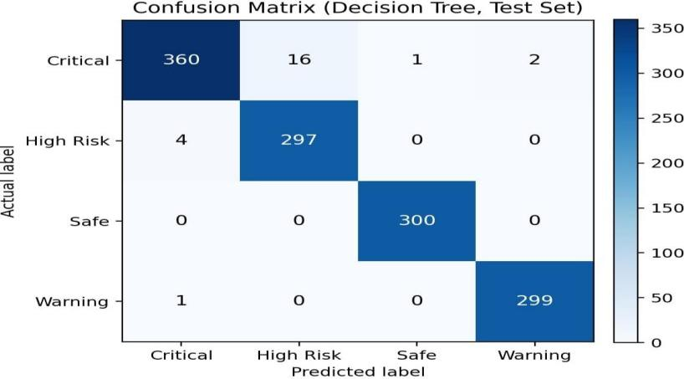
Figure 5.1 Confusion Matrix
The Random Forest classifier achieved an accuracy of 99.06%, while the Decision Tree classifier achieved an accuracy of 98.12%. The Decision Tree model was selected for deployment on the ESP32 because it requires fewer computational resources.(Figure 5.2)
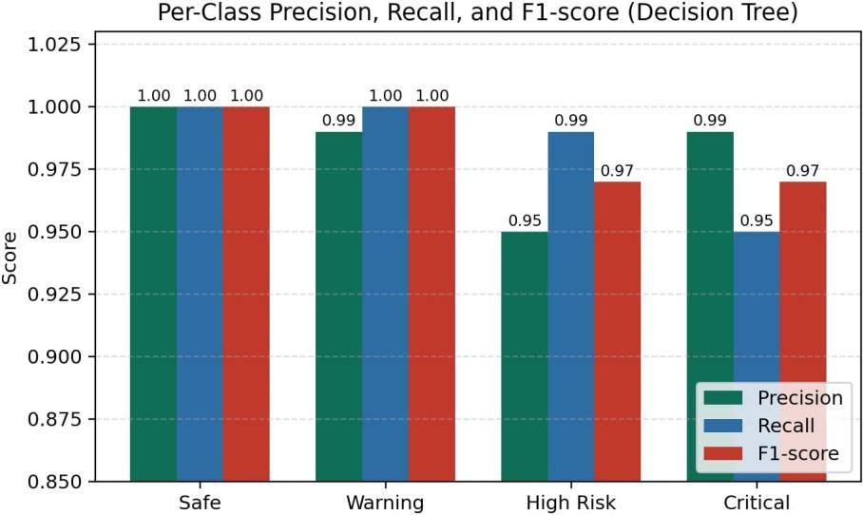
Figure 5.2 Pre Class Precision
The experimental results demonstrated that the model could classify electrical conditions into four risk levels based on temperature, voltage, current, and smoke readings. The system prototype also demonstrated sensor monitoring, relay operation, buzzer activation, GSM-based SMS alerts, and event logging under controlled laboratory conditions. (Figure 5.3)

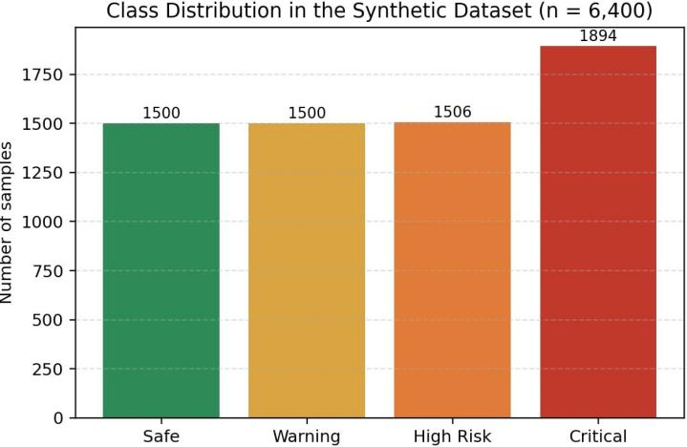
Figure 5.3 Class Distribution

The results indicate that combining IoT sensors with machine learning can support early identification of potential electrical hazards. However, the accuracy values represent performance on the synthetic test dataset and do not establish the probability of preventing real electrical fires. Further evaluation using real-world electrical sensor data, extended hardware testing, and certified protection equipment is necessary before the system can be used in actual household or industrial electrical installations.(Figure 5.4)
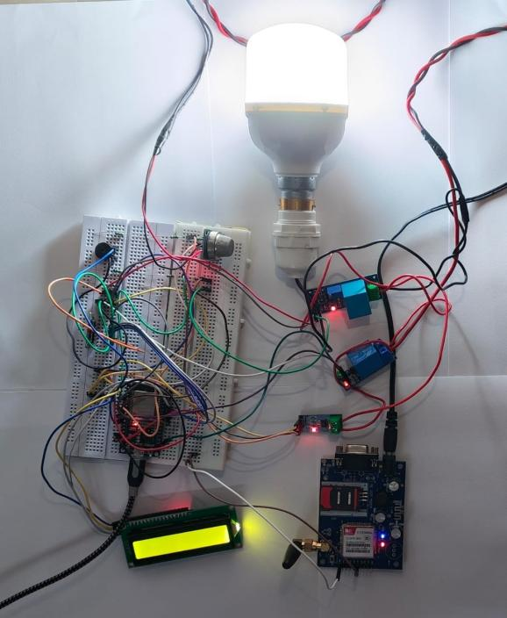
Figure 5.4 Final Output

CHAPTER 6

CONCLUSION AND FUTURE WORK

6.1 CONCLUSION
The AI-Based Electrical Fire Prevention System Using IoT Sensors and Machine Learning was designed and developed to identify potential electrical fire hazards at an early stage. The system uses an ESP32 microcontroller integrated with temperature, voltage, current, and smoke sensors to continuously monitor electrical and environmental conditions.
A machine learning model classifies the detected conditions into four risk levels: Safe, Warning, High Risk, and Critical. The Random Forest model achieved an accuracy of 99.06%, while the lightweight Decision Tree model achieved an accuracy of 98.12% on the test dataset. The Decision Tree model was selected for implementation on the ESP32 because of its simple structure and low computational requirements.
When a critical condition is detected, the system automatically activates a relay to disconnect the prototype load, sounds a buzzer, and sends an SMS alert through the SIM800L GSM module. The system also records sensor readings, risk levels, and events for future analysis.
The prototype was tested in a controlled laboratory environment, demonstrating the integration of IoT sensors, machine learning, automatic response, and alert notification. However, the reported accuracy is based on a synthetic dataset, and the prototype has not been validated for high-current household or industrial applications. Further testing and electrical safety certification are required before practical deployment.

6.2 FUTURE WORK
The proposed system can be improved in several ways to increase its accuracy, reliability, and practical usefulness.
- Real-Time Dataset Collection: Collect real-world electrical sensor data under different operating conditions to improve the reliability of the machine learning model.

- Model Improvement: Explore advanced machine learning algorithms and compare their performance to improve electrical fire-risk classification.

- IoT-Based Remote Monitoring: Develop a web or mobile application to display sensor readings, risk levels, and alerts remotely.
- Enhanced Alert System: Integrate additional notification methods, such as mobile application notifications and email alerts, along with SMS messages.

- Hardware Improvement: Use reliable, calibrated sensors and certified electrical protection components to improve the safety and accuracy of the system.

- Extended Testing: Test the system under different environmental and electrical conditions to evaluate its performance and reliability.

- Industrial Applications: After extensive validation and certification, explore the system's potential use in residential buildings, offices, laboratories, and industrial environments.

REFERENCES:
- J. Mbale and N. Simbeye, “Development of an Intelligent Fire Prevention System Using IoT-Enabled Sensors and Automated Countermeasures,” in Proc. 7th Int. Conf. Information and Communication Technologies (ICICT), Lusaka, Zambia, Oct. 15–16, 2025, pp. 416–421.
- M. Ma, C. Xu, and J. Han, “Application of an Intelligent Electrical Fire Monitoring System Based on the EC-IoT Framework in High-Rise Residential Buildings,” Systems and Soft Computing, vol. 7, Art. no. 200257, Apr. 2025.
- W. Xu, S. C. Chan, and W. Y. Leong, “Effectiveness Study of Artificial Intelligent Facility System in Maintaining Building Fire Safety,” Discrete Dynamics in Nature and Society, vol. 2023, Art. no. 2592322, 2023.
- A. Bayegizova et al., “Fire Detection Using Deep Learning Methods,” International Journal of Electrical and Computer Engineering (IJECE), vol. 14, no. 1, pp. 547–555, 2024.
- M. Khan et al., “ESP32-Based Intelligent Fire Detection System Utilizing Machine Learning and Computer Vision for Enhanced Safety in Indian Micro and Small Enterprises,” 2026.
- A. Elhanashi et al., “Early Fire and Smoke Detection Using Deep Learning: A Comprehensive Review of Models, Datasets, and Challenges,” Applied Sciences, vol. 15, Art. no. 10255, 2025.
- Y. Mastanamma et al., “IoT-Based Multi-Sensor Fire Detection and Automated Suppression System with Electrical Isolation,” International Journal of Research and Applied Science & Engineering Technology (IJRASET), vol. 14, no. 4, pp. 2337–2343, 2026.
- G. P. Emmanuel, J. D. Jiya, Y. H. Shuaibu, J. T. Abraham, R. Ogwu, and L. E. Bitrus, “Intelligent Fire Detection Systems Using Deep Learning and Multi-Sensor Data Fusion: A Comprehensive Review,” International Journal of Scientific Research in Engineering and Development (IJSRED), vol. 8, no. 5, pp. 2346–2357, Sep.–Oct. 2025.
- S. He, J. Guan, J. Wang et al., “Study on Temperature Prediction and Early Warning of Building Resistive Electrical Circuit Fire: A Mathematics Model,” 2025.
- S. He, X. Shu, J. Hu, L. Zhang, J. Zhang, J. Zhang, and Y. Zhou, “Prediction and Early-Warning Method of Electrical Fire Risk Based on Fire-Fighting Big Data,” Journal of Tsinghua University (Science and Technology), vol. 64, no. 3, pp. 478–491, 2024.
- Y. Li, J. Yi, X. Zhu, Z. Wang, and F. Xu, “Developing a Fire Monitoring and Control System Based on IoT,” Advanced Intelligent Systems Research, pp. 174–178, 2016.
- H. Dai, P. Shi, H. Liu, R. Chen, and Z. Chen, “Electrical Fire Monitoring IoT Framework for Ancient Architectural Complex Leveraging Edge Computing,” International Journal of Communication Systems, vol. 35, no. 17, Art. no. e5329, 2022.
- A. Gaur, A. Singh, A. Verma, and A. Kumar, “Artificial Intelligence and Multi-Sensor Fusion Based Universal Fire Detection System for Smart Buildings Using IoT Techniques,” IETE Journal of Research, vol. 69, no. 12, pp. 9204–9216, 2023.
- Y. Wang, Q. Li, J. Zhang, C. Yin, Q. Zhang, Y. Shi, and H. Men, “A Gas Detection System Combined with a Global Extension Extreme Learning Machine for Early Warning of Electrical Fires,” Sensors and Actuators B: Chemical, vol. 423, Art. no. 136801, 2025.
- K. Ko, D. Hwang, S.-J. Park, and G.-G. Moon, “Electrical Fire Prediction Model Study Using Machine Learning,” Journal of the Korea Institute of Information, Electronics, and Communication Technology, vol. 11, no. 6, pp. 703–710, 2018.


